Mechatronic system requirements profile

Contact details:
Company
Contact
Project name / number
Phone number
EMail
JAT contact
Date

Application description of the mechatronic system:
e.g. intended use, operation processes, special requirements, …:

Sketch of the axes’ arrangement (including axis numbering):

Technical system requirements:
Axis | 1 | 2 | 3 | 4
Arrangement (X, Y, Z, D)
Stroke / rotation angle with overflow
Maximum axis lentgh (mounting space)
Velocity
Acceleration
Positioning accuracy
Positioning resolution
Repeatability
Straightness deviation in X
Straightness deviation in X
Straightness deviation in X
Sensors or limit switches necessary?
Holding brake necessary?
Type of measuring system (Sin/Cos, incremental, absolute [protocol BiSS C, Hiperface, …])
Load capacity
Distance from center of mass to axis
Forces in opposite directions (e.g. springs)

Sketch illustrating the definitions (coordinate system required):

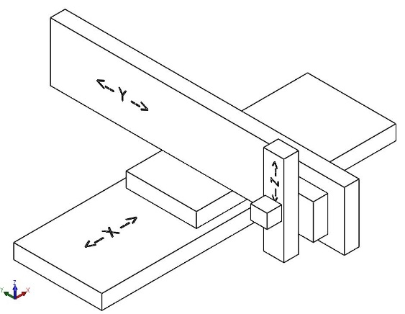

Ambient / operation conditions of the machine:
Ambient temperature
Special ambient conditions (dust, clean room, vibration, x-ray, humidity, …)
Duty cycle during operation [%]
(relation between movement and standstill)
Functional safety (e.g. STO, SLS, …)
Critical positioning time and stroke
Minimum life cycle (amount of operations, time or total travel distance)

Interfaces (mechanical, electrical, control):
Connection of mechanical interface to basic structure (fully faced or self-supportive)
Energy chain implemented by the customer?
Additional cables or tubes (e.g. amount, diameter, dynamic / moving bending radius)
(Excess) length of cables at energy chain outlet
Electrical interface connection (e.g. cable with plug to control cabinet, coupling point, …)
Positioning mode (point-to-point / path)
Field bus interface (e.g. Profibs, Profinet, EtherCAT, CANopen, …)

